**Tips for Normal Vaginal Delivery**

A mother always expects her baby to be healthy and sound. And a normal vaginal delivery is a dream of all young ladies. Almost 85% of women go for normal vaginal delivery as they think this is the only method to give birth to a healthy baby.

But things not always go as they are planned. Sometimes, precautions are necessary to study and take before getting into trouble. Women with a normal physique tend to give birth to a healthy baby without a cesarean. Hence, maintenance of the body before and during pregnancy is a must.

Here, we provide few tips for normal vaginal delivery and how to get normal delivery without pain. Believe me! Education about right things and at right time will be most helpful. And questions like ‘is it possible to give birth normally after a cesarean section?’ are answered at ease.

**Tips for Normal Vaginal Delivery**

A natural birth is admirable to all and some tips about how to get normal delivery without pain are right here. Tips for normal vaginal delivery:

* **Learn about prenatal education**

Search out special classes that give prenatal education. Their topics include natural labor pain management techniques like breathing, self-hypnosis and coping mechanisms to help you relax. Don’t go for pieces of training where cesarean sections are common or preferred the most. Find a good fit training which includes tips for normal delivery in the 9th month.

* **Keep your weight in check**

Don’t put on excess weight before or during pregnancy. Try to maintain your weight and keep it near advised levels. You can calculate your BMI and ask your health caretaker for an expected weight gain chart. Tips for normal vaginal delivery include maintaining a desirable weight.

In addition, women with normal or low weights tend to deliver baby normally. Be smart! Lose some extra weight before pregnancy, if any, for a normal delivery.

* **Choose low intervention**

Other tips for normal vaginal delivery include intake of fewer medicines. Ask about every test you are suggested to take. Interrogate your health provider whether or not the suggested test is necessary. If you think your pregnancy is going smoothly, then you don’t have to go for unnecessary tests or medication.

An associated problem is: if intake of medication increases before labor, a higher dose of medication is required, which leads to complications in delivery to mother as well to baby’s life.

* **Pick a health care provider who chooses normal delivery**

A right person who can guide you the best is the one who himself believes in normal delivery. Here, tips for normal vaginal delivery include adding a trustworthy doctor to your routine. He’ll provide you with good tips for normal delivery in the 9th month and will help you learn important things required before labor.

* **Spend early labor at home**

Early labor is the main stage of pregnancy. Tips for normal vaginal delivery must be high on the priority list. This is to be handled with utmost care and patience. Since a home is the best place to rest, stay home most of the times. This advice doesn’t mean to say, “Lock up yourself in the home”. You can shop things nearby, roam around a while, but in whatever you do, stay near your home or any hospital to reach out in an emergency.

* **Make friends with water**

Spending time in water can relax your body cramps and easing the pain. Get into the bathtub or birth pool; take a shower or hot water bath. Water will cure!

* **Don’t allow stress to kick in**

Use you prenatal education and try to relax. Move around, listen to soft music, get a massage and calm your muscles. It will leave a good impression on your health and on baby’s heart too.

* **Normal delivery exercise routine**

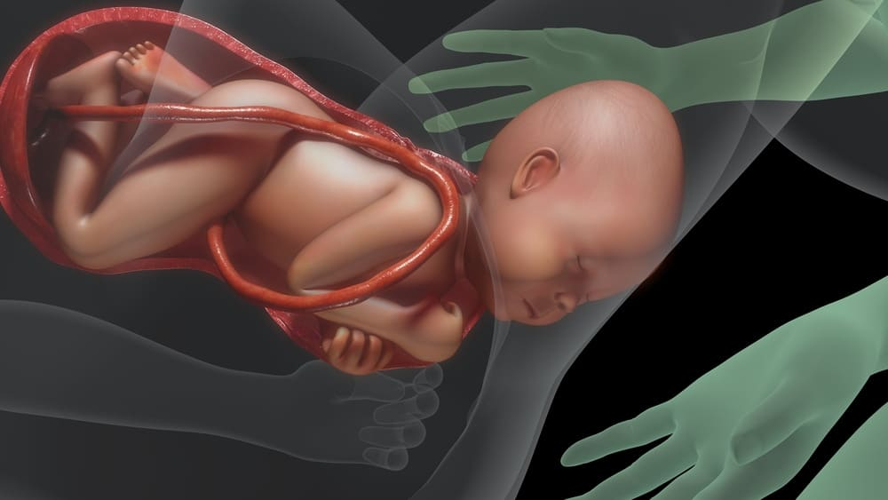There are some light normal delivery exercises that you may follow during the early stages of pregnancy as tips for normal vaginal delivery. Just keep in mind a few things related to normal delivery exercise. Don’t exercise if you’re too tired and abort a particular posture that causes pain.

Now you are aware of the suitable tips for normal delivery in the 9th month. There are some tips for normal delivery to avoid cesarean section lined up for you. You must be wondering: is it possible to give birth normally after a cesarean section? Tips for normal vaginal delivery help in getting through the situation. Go ahead and find out answers to your questions.

**Is it possible to give birth normally after a cesarean section?**

Yes, it surely does. Some complications might pop up to lessen your cheer but after successfully handling them, you can have a normal delivery. Let’s find out how.

* **Choose your health care provider wisely**

Select a specialist whose cesarean rate is less. It’s not necessary to keep the doctor if you don’t find her suitable. You will have your baby only once during a pregnancy; choose the best for him/her. It’s helpful to make visits to the same doctor for every test or medication purposes as she’ll be aware of your conditions already.

* **Hire a doula (an all-time caretaker during pregnancy)**

Doulas make childbirth better and easier for the expectant mother. They are usually hired during pregnancy. She becomes a caretaker, emotional supporter, 24/7 help and a handy person to rely upon during pain. She will also help you with sleeping poses essential to eliminate the cesarean section.

* **Take childbirth classes**

Know about the tips for normal delivery to avoid cesarean and how to get normal delivery without pain in childbirth classes. Trainers train well and according to recent studies. So, if you are likely to miss any elder’s advice during the process, don’t hesitate! Some old remedies are proved worthless nowadays.

* **Avoid medication if there’s nothing serious**

Avoid taking epidural (injections to cure pain) if you can bear the pain. At times, you may feel uneasy and restless. Take a massage or a shower to calm down but don’t rely on medication as far as possible. Along with relief, they build certain problems too.

* **Stay home before labor**

Take rest and stay at home when labor is near.

* **Read only best childbirth books**

There are several light-contented books available to read during pregnancy. They generate positivity in the atmosphere surrounding you. They might help your baby to learn something before stepping out. Just kidding! But books do make an impact on your mind.

* **Share your emotions with your partner**

Walk the journey with your partner. Share your heart feelings and make him your support.

* **Don’t give up**

Pregnant women generally feel lonely and separated from the world. Actually, there are people around you who care. Think about them and take their support. Strengthen yourself. After all, becoming a mother is a very special feeling which is beyond expression!

**Normal Delivery Tips Ayurveda**

Ayurveda offers natural tips for normal vaginal delivery. Normal delivery tips Ayurveda include:

* Walk every day.
* Take milk with garlic paste (from 7 months onwards).
* Consume pomegranate juice daily. It helps to improve blood cells.
* As per Ayurveda, eat a spoonful of honey on commencement of labor pain. Also, apply a paste of honey and black cumin powder over the stomach. It will provide relief.
* Take a warm water bath before going to bed. This relaxes muscles.

**Final words**

The whole write-up contains tips for normal vaginal delivery, tips for normal delivery in the 9th month, tips for normal delivery to avoid cesarean and some normal delivery tips Ayurveda.

This aims to provide a vision to all ladies on how they can spend a healthy pregnancy period and they need not worry about cesarean section if they walk on the right path. Choose among the best tips for normal vaginal delivery after consulting your doctor.